iLand contribution to LP paper

*Questions*

1. how large would lodgepole pine have grown if the experiment had been run for a century?

2. After a century, how does the presence of lodgepole pine alter the size of native tree species and stand-level carbon stocks?

**Methods**

*Model description*

iLand is an individual-based forest process model that simulates the growth and mortality of trees in spatially explicit stands and landscapes based on canopy light interception, climate, and nutrients (Seidl et al. 2012a, 2012b). Individual trees determine light availability at a 2-m spatial resolution within stands. Climate and soil characteristics (percent sand, silt, clay, effective depth, and nutrient availability) are considered to be homogenous at the stand scale (1-ha). iLand is forced with daily temperature, precipitation, shortwave radiation, and vapor pressure deficit. iLand also now includes a permafrost and surface organic layer module that mechanistically simulates daily changes in active layer depth, annual SOL accumulation and decomposition, and their complex ecological effects at the stand scale. When in stand mode, iLand simulates independent forest stands in parallel where neighboring stands do not influence one another. Instead, iLand simulates each stand as if they are ‘wrapped’ where trees on one side of the stand influence trees on the other side, eliminating edge effects. The model has been well tested in landscape and stand modes and applied in the western United States (Hansen et al. 2018, Turner et al. 2022) and Alaska (Hansen et al. 2021).

*Initial conditions*

We initialized iLand with data from 90 boreal-forest stands in interior Alaska. This included the 30 stands used in the lodgepole-pine experiment and 60 surveyed stands that were also dominated by black spruce before burning in 2004, but where lodgepole-pine seedlings were not experimentally planted. Native tree-species (black spruce, trembling aspen, and Alaskan birch) seedling density were set using field measurements, and we assumed native seedlings were between 1 and 3 cm tall. We also initialized lodgepole pine seedlings at densities consistent with the experimental plantings and assumed they were between 6 and 12cm tall when planted. Lodgepole pine were simulated using a parameter set from the northern Rocky Mountains of the western United States (Braziunas et al. 2018). Soil information used to initialize iLand was extracted using geographic coordinates of the 90 stands from the global SoilGrids250m database versions 1.0 (for effective soil depth) and 2.0 (for percent sand, silt, and clay) (Hengl et al. 2017). Relative soil fertility, expressed as plant available nitrogen, was set at 45 kg ha-1 yr-1 (Hansen et al. 2021).

*Simulation experiment*

We conducted simulations to extend the field experiment for 89 years. This allowed us to quantify how large lodgepole pine would have grown over a century and how the experimental addition of lodgepole pine may have altered the size of native tree species and stand-level carbon stocks.

Stands were simulated with and without experimentally planted lodgepole pine forced with 2005-2015 daily climate from the 1-km Daymet product (Thornton et al. 2021) randomly recycled with replacement. For simulations *with* lodgepole pine, we calculated stand-level mean lodgepole pine height and DBH at each of the 90 stands in model year 11 (corresponding to 2015 in the lodgepole pine transplant experiment) and model year 100. To evaluate model skill, we compared stand-level mean lodgepole pine height and DBH with observed mean height and DBH from 2015 at the 30 black spruce stands where lodgepole-pine seedlings were experimentally planted. In model year 100 of simulations *with and without* lodgepole pine, we also calculated stand-level mean height and DBH of the native tree species and calculated total aboveground live (stem,branch, foliage, regeneration) carbon stocks and belowground (SOL, downed wood, coarse roots, fine roots) carbon stocks.

*Results*

Q1 key takeaways

* iLand was skilled at representing the central tendency of mean lodgepole pine sizes in 2015 at the 30 stands where lodgepole pine were experimentally planted, but did not capture the stand-to-stand variability in observed mean lodgepole-pine sizes (Fig. 1).

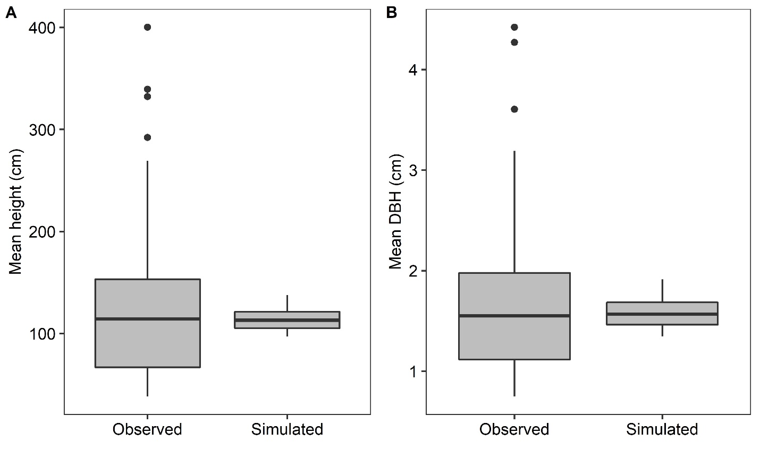

Figure 1. Observed and simulated stand-level mean lodgepole pine (A) height and (B) DBH in 2015 at 30 black spruce stands where lodgepole-pine seedlings were experimentally planted.

* After a century, lodgepole pine were 19m tall on average with a DBH of 27cm (fig 2).

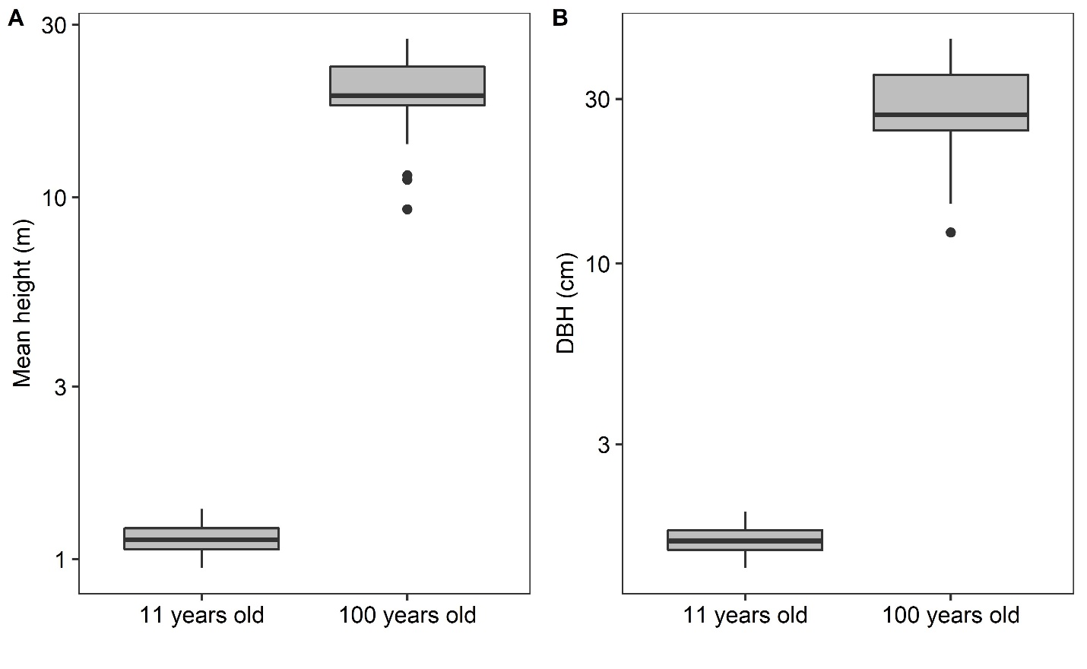

Figure 2. Simulated stand-level mean lodgepole pine (A) height and (B) DBH 11 years postfire and after a century of growth at 90 black spruce stands that burned in the 2004 fires.

Q2 key takeaways

* After a century, the presence of lodgepole pine reduced the stand-level mean height and DBH of native tree species (Fig. 3).

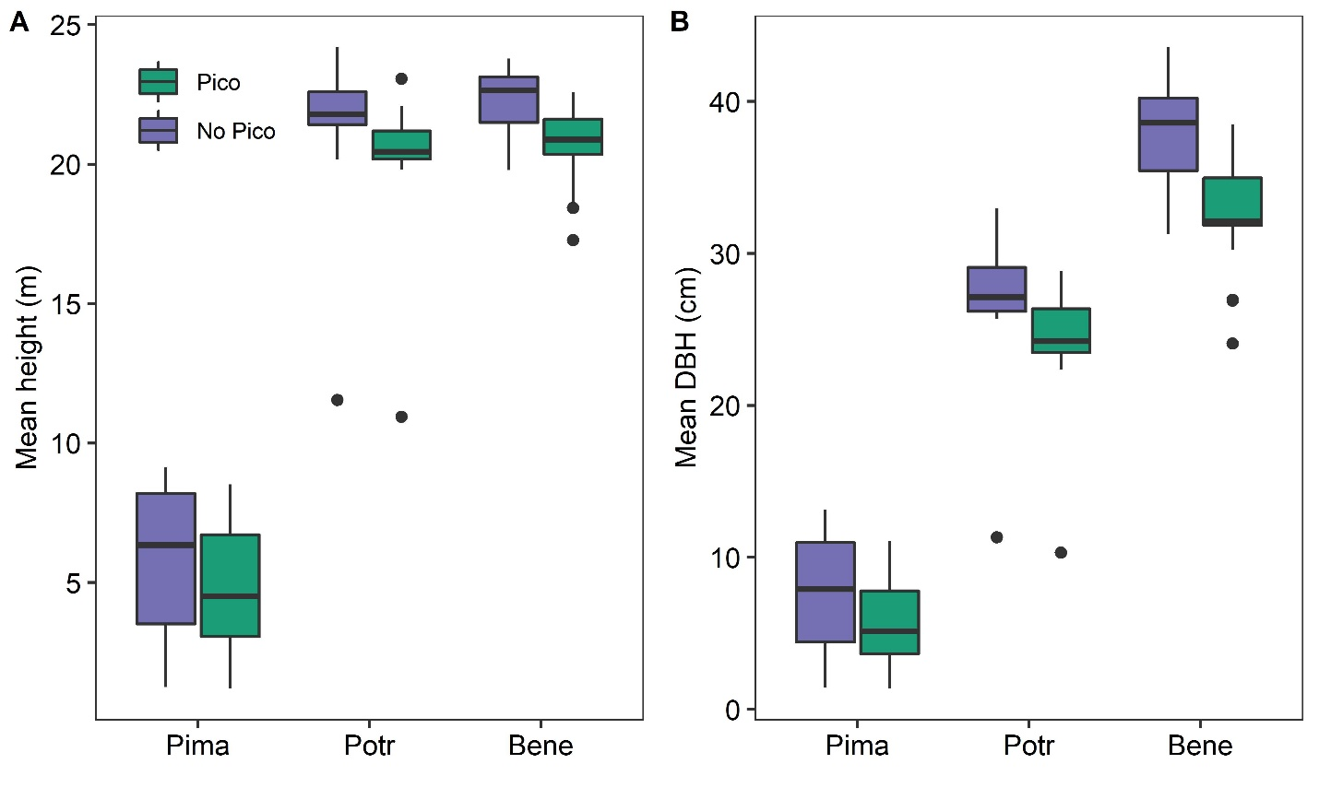

Figure 3. Simulated stand-level mean (A) height and (B) DBH of native tree species after a century of growth at 90 black spruce stands that burned in the 2004 fires. Stands were simulated with and without lodgepole pine (Pico) present.

* However, total aboveground carbon stocks were markedly higher after a century when stands were simulated with lodgepole pine, while belowground carbon stocks did not differ (fig. 4).

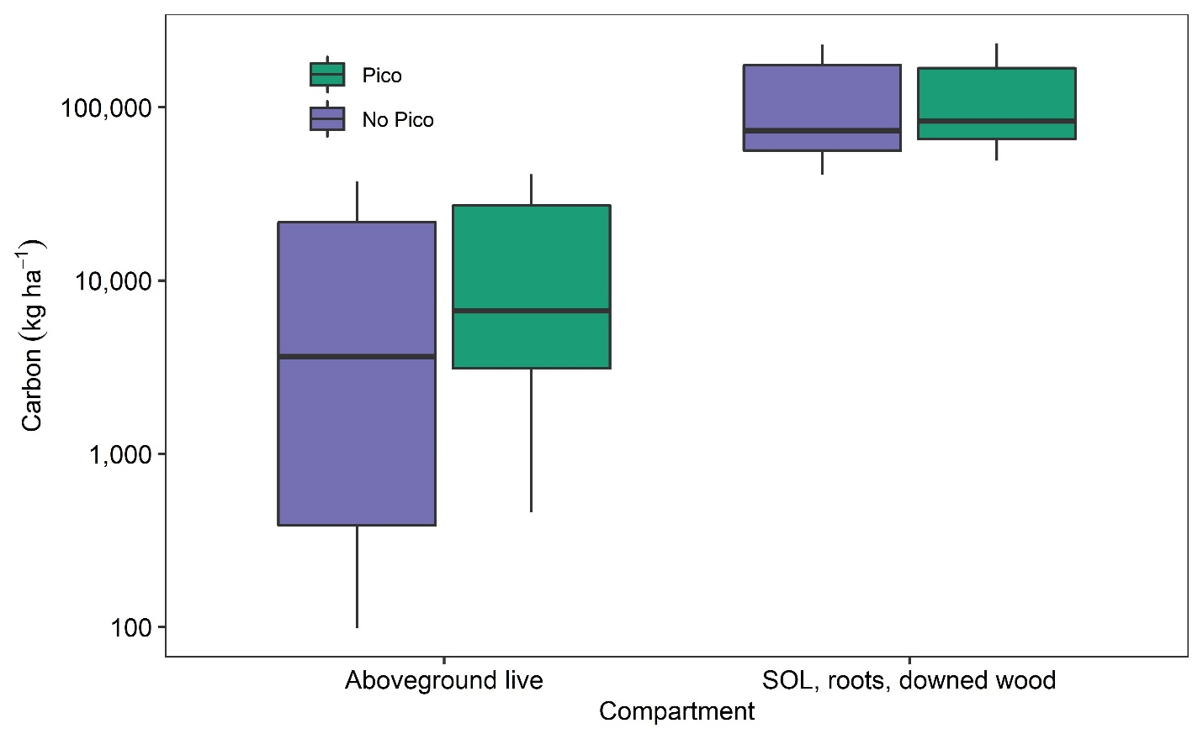

Figure 4. Simulated stand level Aboveground live and belowground carbon stocks after a century of succession at 90 black spruce stands that burned in the 2004 fires. Stands were simulated with and without lodgepole pine (Pico) present.